Test Case for OldPhonePad Console Application

Run the OldPhonePadConsole.exe .

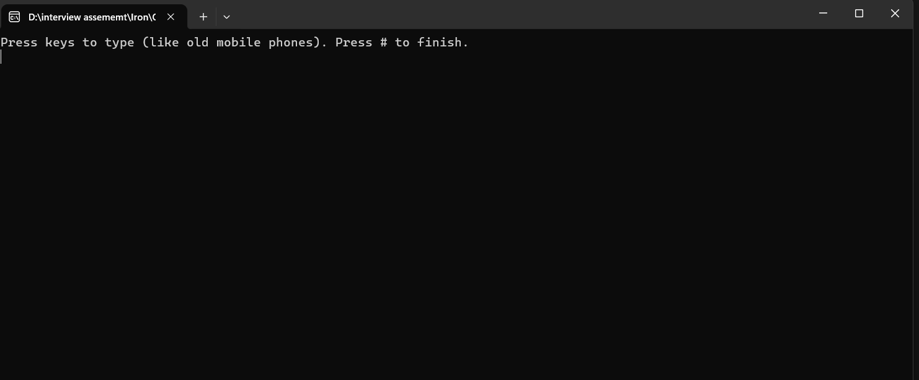

Enter Input and end with ‘#’.

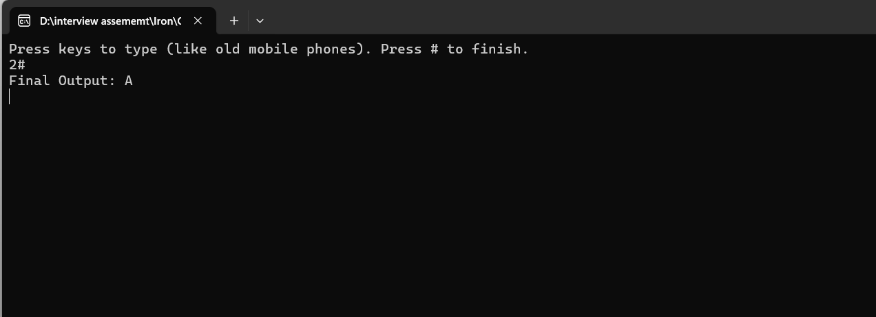

Enter same number 2 times and 3 times to get 2nd and 3rd and 4th character from Phone pad .

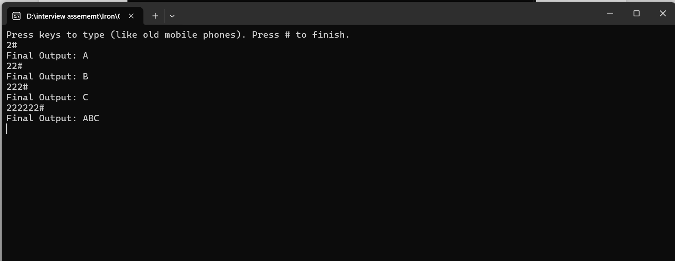

Enter No 1 for special charater like &, ‘ , ( , ) and 0 for space .

